**Ocean Acidification – Southeast Alaska**

**Integrated Study**

**Rachel Carson 0083 Cruise Report**

Chief Scientist: Jessica Cross, NOAA Pacific Marine Environmental Lab

**Table of Contents**

Section A: Overview 3

A note on the use of R/V Carson 5

Station Location Table, with Samples Collected 7

Section B: Hydrographic Measurements 11

Brief Highlights. 11

Section C: Bottle oxygen and nutrients 14

Oxygen 14

Macronutrients 14

Section D: 𝛿 18O 15

Section E: Carbonate Chemistry 15

Usage Guidelines 15

Section F: Environmental DNA (eDNA) 16

Section G: Glider 18

Section H: Outreach 20

# Section A: Overview

As part of its sustained investment portfolio, the NOAA Ocean Acidification Program (OAP) supports the Pacific Marine Environmental Laboratory (PMEL) to conduct Observations of Ocean Acidification in Alaska Coastal Seas through the maintenance of two ocean acidification (OA) mooring sites in critical fishing areas and a single OA hydrographic survey along the continental shelf of the Gulf of Alaska. Delayed since 2018, the planned hydrographic survey took place aboard UNOLS Research Vessel Rachel Carson (UW) from 8 – 31 August. The overall goal of this mission is to track acidification conditions in the regional Gulf of Alaska system, in support of maintaining regional time series, updating regional biogeochemical algorithms, and leading towards the development of an ocean acidification indicator.

The main objectives for this mission were (1) to revisit as many off-shelf lines conducted during the previous (first) Gulf of Alaska ocean acidification survey in 2015; (2) to recover a SLOCUM glider deployed by Rutgers University approximately one month prior to the mission; (3) to complete deep casts sufficient to collect deep water that should cross calibrate the 2022 mission to the 2015 mission and to calibrate the operation of the glider’s pH sensor at dept; (4) to collect biodiversity data through environmental DNA sampling (eDNA) throughout the mission.

The list of activities and associated PIs is as follows:

* Hydrographic measurements: Jessica Cross, NOAA-PMEL and Natalie Monacci, CICOES / UAF Ocean Acidification Research Center
* Bottle oxygen and nutrients: Calvin Mordy, CICOES / University of Washington
* Stable nitrogen isotopes: Angela Knapp, Florida State University
* Carbonate chemistry: Jessica Cross, NOAA-PMEL and Natalie Monacci, CICOES / UAF Ocean Acidification Research Center
* Environmental DNA: Matt Galaska, CICOES / University of Washington
* Slocum glider deployment: Grace Saba, Rutgers University
* Outreach: Adi Hanein, NOAA-PMEL and Natalie Monacci, CICOES / UAF Ocean Acidification Research Center

Given this mission has been rescoped multiple times due to various challenges, including lapses in appropriations; vessel availability; and the global COVID-19 pandemic, we are proud to report that we were able to complete all of the mission-critical objectives listed above. Unfavorable weather conditions offshore prevented this mission from proceeding north of Sitka to obtain more data complementary to the 2015 mission. However, we were able to use the time regained to the hard work and dedication of the Carson’s crew, as well as our planned weather days, to complete a survey of interior Alaska, including multiple short-term requests for data from our colleagues across the OA community. This including sampling in Glacier Bay National Park, for which the park superintendent approved a short-term permit for our research work given the high-value they placed on the potential data collected; sampling in Lynn Canal and Chatham Strait, along which our colleague Wiley Evans had previously collected corrosive surface data through the Alaska Marine Highway System; and a survey of the other major waterways of SE Alaska, including time series stations in Icy Strait and Stephens Passage from our colleagues at the National Marine Fisheries Service Alaska Fisheries Science Center (NMFS AFSC) and stations in Frederick Sound, Clarence Strait, and Revillagigedo Canal that are otherwise relevant to the aquaculture industry in SE Alaska and were requested by the Alaska Ocean Observing System Ocean Acidification Network. While we were pleased to conduct these surveys for the benefit of our colleagues, we filled almost double the number of bottles that we were funded to collect and still ran short of bottles to sample in Frederick Sound, Clarence Strait, and Revillagigedo Canal. Nonetheless, we continued to use our DAS to drop the CTD given that we had a pH sensor installed on the CTD package. We hope that as with our autonomous pH glider, we may be able to calibrate this sensor such that we still receive high-quality carbonate chemistry data from these stations.

Overall, we occupied many additional transects and collected a significantly larger number of samples (460) than originally envisioned (230). A map of the station sites is shown below.

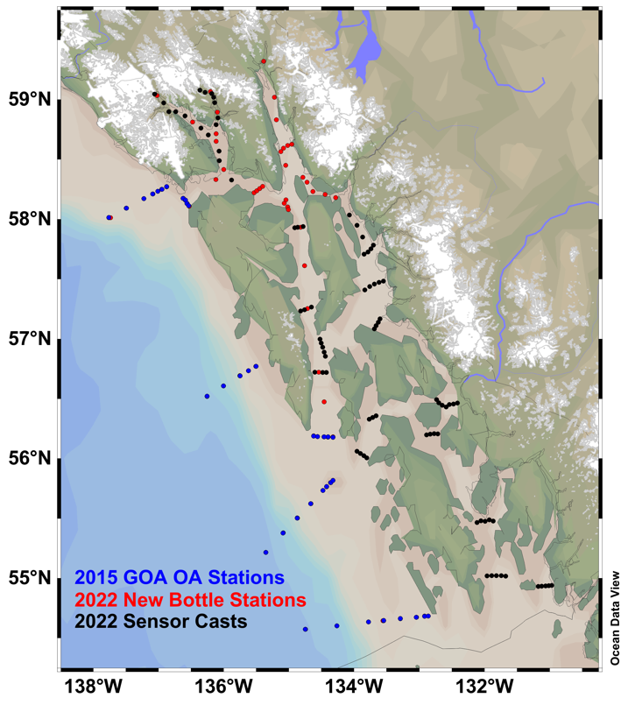

Below are the individual reports for each component of the mission. These include descriptions of the operations, locations of sampling, and, where possible, some brief highlights of initial results. We acknowledge the captain and crew R/V Carson, whose hard work and dedication enabled us to carry out our science operations in a safe and productive environment. The UNOLS Marine Technicians onboard kept the ship’s science systems and sensors running smoothly throughout the mission. We also thank NOAA’s Ocean Acidification Program and the Alaska Ocean Observing System for supporting this work. Last, we thank our colleagues of opportunity at Glacier Bay National Park, the Hakai Research Institute, and the Alaska Fisheries Science Center for their support in rapidly replanning this work due to the offshore weather system that prevented us from getting further north. Natalie Monacci is owed a special thanks for her shore-side support in coordinating with these various bodies while our shipboard connectivity was limited.

## A note on the use of R/V Carson

At all stages of this mission, the captain and crew of R/V Carson conducted themselves and their vessel admirably and with the utmost professionalism. We completed 100% of the mission objectives, including recovery of a SLOCUM glider, 6 offshore hydrographic sampling lines, and 2 deep casts > 1000 m (double what we initially envisioned) and substantially more work than was originally requested. In general, we find that this vessel is capable of handling the work and conditions required by the Ocean Acidification Program and recommend her to our colleagues and the OA Program for future use. However, given that this mission was originally planned for a much larger vessel, we thought it appropriate to provide a brief assessment of this vessel for the conduct of future work in this region, both onshore and offshore.

R/V Carson is a 72 ft research vessel that advertises a 9 kt cruising speed. We found that this was a perfectly reasonable assumption and that R/V Carson readily attained this speed especially on long transits, while 8.25 kt was a more typical average inter-station speed given acceleration and deceleration. The captain and crew of R/V Carson do not place strict wind, seastate, or other weather limits on operations. In general, we found Carson to fall into the category of a “big small boat.” Science operations were safely conducted during periods of 45 kt – 60 kt gusts in the long fetch of Lynn Canal; although wet, the wind chop proved entirely manageable in this situation. Further, R/V Carson conducted safe deep casts offshore in 6-7 ft swells with a relatively short wave period; adept handling of the vessel despite lack of dynamic position controls ensured a safe wire angle with limited tension shock to the wire, and a safe wire wrap on the winch drum.

It is critical to note that safe handling of the vessel in these conditions is essential: poor handling during extreme conditions that results in substantial slack of the wire line at an unfavorable (ship-ward) wire angle can allow the winch wire to wrap around the vessel prop, which is both a danger to the equipment and to the safety of the vessel and requires specialized support (technical divers) to remedy. In addition to handling poor weather conditions admirably, the Carson also demonstrated adept boat handling during the recovery of a SLOCUM glider. The captain achieved ideal positioning and speed on the first pass by the glider; the mates, deckhands, and marine techs latched to the glider’s surface expression at the first pass; and the glider was lifted on board and installed in its cradle seamlessly, at the first pass. Having witnessed multiple approaches of vessels towards autonomous vehicles previously, I was extremely impressed by the smooth handling in this case. Captain Brian Bare has an unsurpassed technical skill and surgical accuracy with positioning.

Where operations were diverted due to weather, this was not due to the capabilities of the vessel but for continuing science operations efficiently. In large swells, our science party in 2022 struggled with seasickness, limiting a safe workforce to just 1 scientist per shift at one point. Further, limited leeward shelter in the potential operating area would not have allowed for those members of the science party to recover between potential weather windows for safe operations. While R/V Carson and her crew may have been able to complete safe operations in the potential weather system we confronted, the science party would not have been able to do so.

For the interests of the typical multi-disciplinary mission typically undertaken by the NOAA Ocean Acidification Program, the primary limitation for use of the R/V Carson is the science complement: For multi-day operations, the vessel can house 13 personnel; during 24-hour operations, this amounts to 7 crew (1 captain, 2 mates, 2 deckhands, and 2 UNOLS marine technicians) and up to 6 scientists. During 12-hour operations, this amounts to 5 crew (1 captain, 1 mate, 2 deckhands, and 1 UNOLS marine technician) and up to 8 scientists. (While less relevant for operations in Alaska, the Carson can support up to 28 persons for daily operations, with the complement of crew and scientists varying according to the needs of the mission.) Given the kind of deeply multidisciplinary work encouraged by the Ocean Acidification Program, this is a substantive limitation. Typical berthing components for various essential on-board work are as follows:

| Sampling Type | Persons per 12 hour shift | Persons required for 24 ops |
| --- | --- | --- |
| Hydrographic Sampling | 2 | 4 |
| Winkler Titrations | 1 | 2 |
| eDNA filtering | 1 | 2 |
| Chl filtering (bulk or size-fractionated) | 1 | 2 |
| Phytoplankton tows / HABs tows | 1 | 2 |
| Zooplankton tows | 2 | 4 |

The small multi-day berthing component on R/V Carson precludes the type of larger multidisciplinary missions, and requires a pared-down version of typical OAP sampling. We were able to complete hydrographic sampling and eDNA filtering with just 4 scientific personnel on board during 2022, though this sometimes required a pause in operations to sustain eDNA capacity. Further, sailing with this small complement also comprises a risk, in that seasickness in science personnel becomes a major challenge. At one point, we had only 2 scientists healthy, each working a 12 hour shift alone. We strongly recommend bringing at least 3 persons for science during each 12 hour shift. While this may make the ship feel more crowded, it will enable continuous operations without straining the science party or eliminating sampling.

In addition to limitations in personnel for multi-day missions, R/V Carson also has limited lab space for the storage of scientific equipment and at-sea analysis. The dry lab is typically used as the main seat of operations for marine technicians, and comfortably seats only 1 additional scientist full time per shift. Otherwise, computer work must be conducted in the wet lab, galley when appropriate, or on deck when favorable. The wet lab has 9 continuous feet of bench space (including no seating) and extremely limited storage; for even our pared-down scientific mission, we stored approximately 1/3 of our nonessential bottle supplies on the back deck. In our assessment, the wet lab on R/V Carson may support any 3 of the following operations during multi-day missions, and any 4 if pressed: hydrographic sampling, Winkler titrations, eDNA filtering, chl-a filtering (bulk or size-fractionated), phytoplankton tows, or zooplankton tows. Although bench and storage space on board R/V Carson was limited, we found there to be adequate refrigerator and freezer space for the storage of scientific samples.

In summary, we find the vessel and crew of R/V Carson capable of operations onshore and offshore in multiple types of weather conditions. The vessel’s primary limitations are her scientific berthing complement for multi-day missions scientific personnel and laboratory bench and storage space.

## Station Location Table, with Samples Collected

Color Coding:

| 2015 Station |  |  |  |  |  |  |  |  |  |
| --- | --- | --- | --- | --- | --- | --- | --- | --- | --- |
| NMFS Request |  |  | | |  |  |  |  |  |
| NPS Request |  |  |  |  |  |  |  |  |  |
| Hakai Request |  |  |  |  |  |  |  |  |  |
| AOOS Request |  |  |  |  |  |  |  |  |  |

| **Cast** | **Station** | **yyyy-mm-ddThh:mm:ss.sss UTC** | **Lon (°E)** | **Lat (°N)** | **O2** | **DIC** | **d18O** | **Nuts** | **eDNA**  *\* : NC* | **Knapp** |
| --- | --- | --- | --- | --- | --- | --- | --- | --- | --- | --- |
| 1 | DE1 | 2022-08-12T03:46:21.000 | 227.14217 | 54.68333 | Bottom | 5 | 3 | 5 | 3* |  |
| 2 | DE2 | 2022-08-12T04:38:53.000 | 227.086 | 54.68184 | Surface | 6 | 2 | 6 |  |  |
| 3 | DE3 | 2022-08-12T05:42:01.000 | 226.95883 | 54.673 |  | 8 | 3 | 8 |  |  |
| 4 | DE4 | 2022-08-12T07:22:27.000 | 226.7135 | 54.66217 | Bottom | 10 | 3 | 10 | 3 |  |
| 5 | DE5 | 2022-08-12T09:21:35.000 | 226.44667 | 54.644 |  | 10 | 2 | 10 |  |  |
| 6 | DE6 | 2022-08-12T11:05:10.000 | 226.2235 | 54.6345 | Surface | 9 | 3 | 9 | 3 |  |
| 7 | DE7 | 2022-08-12T13:17:36.000 | 225.73833 | 54.6015 |  | 10 | 2 | 10 |  |  |
| 8 | DE8 | 2022-08-12T15:42:24.000 | 225.25667 | 54.573 | Bottom Duplicate | 10 | 3 | 10 | 3 |  |
| 9 | POW8 | 2022-08-12T22:34:59.000 | 224.64983 | 55.21433 | Deep Profile (8) | 12 | 12 | 12 | 3 | 12 |
| 10 | POW7 | 2022-08-13T01:11:18.000 | 224.91183 | 55.37733 |  | 10 | 2 | 10 |  | 8 |
| 11 | POW6 | 2022-08-13T02:58:15.000 | 225.13266 | 55.50217 | Bottom | 9 | 3 | 9 |  | 7 |
| 12 | POW5 | 2022-08-13T04:34:00.000 | 225.34 | 55.62117 |  | 8 | 2 | 8 |  | 6 |
| 13 | POW4 | 2022-08-13T05:59:07.000 | 225.52684 | 55.73267 | Surface | 6 | 3 | 6 | 3 | 5 |
| 14 | POW3 | 2022-08-13T07:08:13.000 | 225.58316 | 55.76367 |  | 5 | 3 | 5 |  | 4 |
| 15 | POW2 | 2022-08-13T08:05:54.000 | 225.64417 | 55.797 | Bottom | 5 | 3 | 5 | 3 | 5 |
| 16 | CS1 | 2022-08-13T14:56:51.000 | 225.67984 | 56.17983 |  | 5 | 2 | 5 |  |  |
| 17 | CS2 | 2022-08-13T15:43:07.000 | 225.59917 | 56.17916 | Surface | 9 | 3 | 9 | 3 |  |
| 18 | CS3 | 2022-08-13T16:55:27.000 | 225.54283 | 56.1815 | Bottom | 8 | 3 | 8 |  |  |
| 19 | CS4 | 2022-08-13T18:13:01.000 | 225.44116 | 56.1835 |  | 8 | 2 | 8 |  |  |
| 20 | CS5 | 2022-08-13T19:18:30.000 | 225.38066 | 56.18917 | Surface | 8 | 3 | 8 | 3 |  |
| 21 | SEC0 | 2022-08-14T19:17:58.000 | 224.49699 | 56.77083 | Bottom | 4 | 3 | 4 | 3 |  |
| 22 | SEC05 | 2022-08-14T20:04:00.000 | 224.383 | 56.73383 | Surface | 6 | 3 | 6 |  |  |
| 23 | SEC03 | 2022-08-14T21:02:40.000 | 224.25267 | 56.69167 |  | 8 | 2 | 8 | 3 |  |
| 24 | SEC04 | 2022-08-14T22:41:56.000 | 224.00217 | 56.60683 | Bottom | 10 | 3 | 10 |  |  |
| 25 | SEC05 | 2022-08-15T00:24:06.000 | 223.74683 | 56.51833 | Deep Profile (8) | 12 | 12 | 12 | 3 | 12 |
| 26 | LC05 | 2022-08-17T16:53:25.000 | 224.61717 | 59.319 | Bottom, Surface | 8 | 8 | 8 | 3 |  |
| 27 | LC04 | 2022-08-17T20:53:06.000 | 224.78033 | 59.01867 |  | 6 |  | 6 |  |  |
| 28 | LC03 | 2022-08-17T22:51:05.000 | 224.81284 | 58.83067 | Bottom, Surface | 5 | 5 | 5 | 3 |  |
| 29 | JH1 | 2022-08-18T01:04:29.000 | 225.048 | 58.6255 |  | 4 |  | 4 | 3 |  |
| 30 | LC2 | 2022-08-18T01:34:01.000 | 224.98599 | 58.61583 |  | 8 |  | 8 | 3 |  |
| 31 | JH2 | 2022-08-18T02:27:57.000 | 224.92216 | 58.59217 |  | 4 |  | 4 |  |  |
| 32 | JH3 | 2022-08-18T03:14:58.000 | 224.88133 | 58.56367 |  | 4 |  | 4 | 3 |  |
| 33 | LC01 | 2022-08-18T04:23:59.000 | 224.95599 | 58.45067 | Bottom, Surface | 8 | 8 | 8 | 3* |  |
| 34 | UCD | 2022-08-18T07:04:40.000 | 224.95917 | 58.1605 |  | 6 | 2 | 6 |  |  |
| 35 | UCC | 2022-08-18T07:40:47.000 | 224.93333 | 58.13217 | Surface | 4 |  | 4 | 3 |  |
| 36 | UCB | 2022-08-18T08:22:02.000 | 224.98483 | 58.10283 |  | 4 |  | 4 |  |  |
| 37 | UCA | 2022-08-18T09:04:23.000 | 224.99716 | 58.079 | Surface | 8 | 2 | 8 | 3 |  |
| 38 | ISA | 2022-08-18T11:39:46.000 | 224.46983 | 58.221 | Surface | 4 | 2 | 4 | 2 |  |
| 39 | ISB | 2022-08-18T12:25:20.000 | 224.5105 | 58.23633 |  | 4 |  | 4 |  |  |
| 40 | ISC | 2022-08-18T13:05:02.000 | 224.55684 | 58.2545 |  | 4 |  | 4 |  |  |
| 41 | ISD | 2022-08-18T13:46:22.000 | 224.60017 | 58.27283 | Bottom | 4 | 2 | 4 | 2 |  |
| 42 | XS1 | 2022-08-18T21:43:42.000 | 223.4735 | 58.10883 | Bottom | 5 | 2 | 5 | 3 |  |
| 43 | XS2 | 2022-08-18T22:19:16.000 | 223.4425 | 58.12983 |  | 9 | 2 | 9 | 3 |  |
| 44 | XS3 | 2022-08-18T23:17:27.000 | 223.41833 | 58.15767 | Surface | 9 | 3 | 9 |  |  |
| 45 | XS4 | 2022-08-19T00:09:40.000 | 223.38451 | 58.17367 | Bottom | 5 | 3 | 5 | 3 |  |
| 46 | SEM30 | 2022-08-19T04:29:14.000 | 222.26767 | 58.01117 | Surface | 6 | 3 | 6 | 3 |  |
| 47 | SEM20 | 2022-08-19T05:56:59.000 | 222.50967 | 58.09217 |  | 6 | 2 | 6 |  |  |
| 48 | SEM10 | 2022-08-19T07:25:00.000 | 222.77766 | 58.17167 | Bottom | 6 | 3 | 6 | 3 |  |
| 49 | SEM05 | 2022-08-19T08:16:29.000 | 222.91451 | 58.21083 |  | 6 | 2 | 6 |  |  |
| 50 | SEM2.5 | 2022-08-19T09:01:05.000 | 222.994 | 58.2335 | Surface | 6 | 3 | 6 | 3 |  |
| 51 | SEM0 | 2022-08-19T09:41:15.000 | 223.0555 | 58.24983 |  | 6 | 2 | 6 |  |  |
| 52 | SEM-2.5 | 2022-08-19T10:19:54.000 | 223.12784 | 58.27067 | Surface | 5 | 3 | 5 | 3 |  |
| 53 | GB24 | 2022-08-19T13:35:11.000 | 223.88367 | 58.33067 | Bottom | 5 | 3 | 5 | 3 | 5 |
| 54 | GB21 | 2022-08-20T02:46:11.000 | 222.94617 | 59.04517 | Sensor Cast | | | | | |
| 55 | GB12 | 2022-08-20T03:19:15.000 | 222.98267 | 59.03267 | Bottom | 6 | 3 | 6 | 3 |  |
| 56 | GB11 | 2022-08-20T04:11:54.000 | 223.08533 | 58.97133 | Sensor Cast | | | | | |
| 57 | GB10 | 2022-08-20T05:02:40.000 | 223.16116 | 58.8985 | Sensor Cast | | | | | |
| 58 | GB09 | 2022-08-20T05:44:49.000 | 223.26767 | 58.89783 | Sensor Cast | | | | | |
| 59 | GB08 | 2022-08-20T06:38:02.000 | 223.411 | 58.86383 | Sensor Cast | | | | | |
| 60 | GB07 | 2022-08-20T07:32:43.000 | 223.52567 | 58.81167 | Surface | 6 | 3 | 6 | 2 | 6 |
| 61 | GB06 | 2022-08-20T08:31:42.000 | 223.65617 | 58.76 | Sensor Cast | | | | | |
| 62 | GB05 | 2022-08-20T14:26:01.000 | 223.76616 | 58.70383 | Sensor Cast | | | | | |
| 63 | GB13 | 2022-08-20T15:08:42.000 | 223.88567 | 58.714 | Bottom | 5 | 3 | 5 | 3 | 5 |
| 64 | GB14 | 2022-08-20T15:57:05.000 | 223.8895 | 58.7895 | Sensor Cast | | | | | |
| 65 | GB15 | 2022-08-20T16:35:21.000 | 223.91499 | 58.84617 | Sensor Cast | | | | | |
| 66 | GB16 | 2022-08-20T17:36:24.000 | 223.90649 | 58.89383 | Bottom | 6 | 3 | 6 | 3 | 6 |
| 67 | GB17 | 2022-08-20T18:55:28.000 | 223.86366 | 58.97417 | Sensor Cast | | | | | |
| 68 | GB18 | 2022-08-20T19:34:21.000 | 223.851 | 59.01867 | Sensor Cast | | | | | |
| 69 | GB19 | 2022-08-20T20:09:39.000 | 223.81967 | 59.0495 | Sensor Cast | | | | | |
| 70 | GB20 | 2022-08-20T20:35:36.000 | 223.80051 | 59.065 | Bottom | 5 | 3 | 5 | 3* | 5 |
| 71 | GB22 | 2022-08-20T21:29:06.000 | 223.71683 | 59.0585 | Sensor Cast | | | | | |
| 72 | GB23 | 2022-08-20T22:10:20.000 | 223.6405 | 59.07784 | Sensor Cast | | | | | |
| 73 | GB04 | 2022-08-21T01:46:38.000 | 223.88766 | 58.65017 | Bottom | 6 | 3 | 6 | 3* | 6 |
| 74 | GB03 | 2022-08-21T02:40:00.000 | 223.933 | 58.56933 | Sensor Cast | | | | | |
| 75 | GB02 | 2022-08-21T03:18:24.000 | 223.93634 | 58.48883 | Sensor Cast | | | | | |
| 76 | GB01 | 2022-08-21T04:04:57.000 | 224.00534 | 58.414 | Bottom | 4 | 2 | 4 | 2 | 4 |
| 77 | GB00 | 2022-08-21T17:07:16.000 | 224.12316 | 58.32632 | Sensor Cast | | | | | |
| 78 | LFC | 2022-08-21T23:13:56.000 | 225.21817 | 58.35017 | Bottom | 4 | 2 | 4 | 2 |  |
| 79 | SPD | 2022-08-21T23:54:28.000 | 225.28133 | 58.308 |  | 4 | 2 | 4 |  |  |
| 80 | SPC | 2022-08-22T00:40:40.000 | 225.36951 | 58.2315 | Surface | 4 | Bottom | 4 | 2 |  |
| 81 | SPB | 2022-08-22T01:33:07.000 | 225.55783 | 58.20617 |  | 4 | 2 | 4 |  |  |
| 82 | SPA | 2022-08-22T02:20:40.000 | 225.72084 | 58.17933 | Bottom | 4 | Bottom | 4 | 2 |  |
| 83 | SPE | 2022-08-22T03:54:16.000 | 225.93266 | 58.035 | Sensor Cast | | | | | |
| 84 | SPF | 2022-08-22T04:46:57.000 | 226.0495 | 57.9475 | Sensor Cast | | | | | |
| 85 | SPG | 2022-08-22T05:47:14.000 | 226.13516 | 57.8505 | Sensor Cast | | | | | |
| 86 | SPH1 | 2022-08-22T06:48:19.000 | 226.29849 | 57.78283 | Sensor Cast | | | | | |
| 87 | SPH2 | 2022-08-22T07:34:53.000 | 226.26151 | 57.75183 | Sensor Cast | | | | | |
| 88 | SPH3 | 2022-08-22T08:06:45.000 | 226.2155 | 57.72533 | Sensor Cast | | | | | |
| 89 | SPH4 | 2022-08-22T08:41:00.000 | 226.15517 | 57.70617 | Sensor Cast | | | | | |
| 90 | SPI | 2022-08-22T10:50:32.000 | 226.45267 | 57.48233 | Sensor Cast | | | | | |
| 91 | SPJ | 2022-08-22T11:27:33.000 | 226.38651 | 57.47167 | Sensor Cast | | | | | |
| 92 | SPK | 2022-08-22T12:10:44.000 | 226.31583 | 57.45767 | Sensor Cast | | | | | |
| 93 | SPL | 2022-08-22T12:37:33.000 | 226.242 | 57.436 | Sensor Cast | | | | | |
| 94 | SPM | 2022-08-22T13:10:59.000 | 226.166 | 57.40833 | Sensor Cast | | | | | |
| 95 | FSA | 2022-08-22T15:12:27.000 | 226.40199 | 57.16683 | Sensor Cast | | | | | |
| 96 | FSB | 2022-08-22T15:41:17.000 | 226.37267 | 57.13717 | Sensor Cast | | | | | |
| 97 | FSC | 2022-08-22T16:06:42.000 | 226.34151 | 57.10883 | Sensor Cast | | | | | |
| 98 | FSD | 2022-08-22T16:28:55.000 | 226.314 | 57.082 | Sensor Cast | | | | | |
| 99 | WI7 | 2022-08-22T23:31:32.000 | 227.26717 | 56.49183 | Sensor Cast | | | | | |
| 100 | WI6 | 2022-08-22T23:55:31.000 | 227.30051 | 56.46583 | Sensor Cast | | | | | |
| 101 | WI5 | 2022-08-23T00:22:48.000 | 227.355 | 56.44383 | Sensor Cast | | | | | |
| 102 | WI4 | 2022-08-23T00:50:52.000 | 227.41484 | 56.43 | Sensor Cast | | | | | |
| 103 | WI3 | 2022-08-23T01:18:26.000 | 227.46483 | 56.451 | Sensor Cast | | | | | |
| 104 | WI2 | 2022-08-23T01:43:30.000 | 227.526 | 56.45567 | Sensor Cast | | | | | |
| 105 | WI1 | 2022-08-23T02:09:40.000 | 227.58684 | 56.46267 | Sensor Cast | | | | | |
| 106 | UCLS1 | 2022-08-23T04:52:22.000 | 227.28767 | 56.20583 | Sensor Cast | | | | | |
| 107 | UCLS2 | 2022-08-23T05:23:20.000 | 227.22966 | 56.208 | Sensor Cast | | | | | |
| 108 | UCLS3 | 2022-08-23T05:51:26.000 | 227.17183 | 56.20367 | Sensor Cast | | | | | |
| 109 | UCLS4 | 2022-08-23T06:14:18.000 | 227.11517 | 56.19783 | Sensor Cast | | | | | |
| 110 | USS1 | 2022-08-23T09:26:08.000 | 226.34166 | 56.35617 | Sensor Cast | | | | | |
| 111 | USS2 | 2022-08-23T09:44:35.000 | 226.289 | 56.34267 | Sensor Cast | | | | | |
| 112 | USS3 | 2022-08-23T10:08:31.000 | 226.2365 | 56.32784 | Sensor Cast | | | | | |
| 113 | LSS1 | 2022-08-23T12:32:31.000 | 226.19917 | 56.00533 | Sensor Cast | | | | | |
| 114 | LSS2 | 2022-08-23T12:59:57.000 | 226.15134 | 56.02234 | Sensor Cast | | | | | |
| 115 | LSS3 | 2022-08-23T13:33:50.000 | 226.10167 | 56.04067 | Sensor Cast | | | | | |
| 116 | LSS4 | 2022-08-23T14:04:12.000 | 226.04716 | 56.0605 | Sensor Cast | | | | | |
| 117 | MCS1 | 2022-08-23T18:32:24.000 | 225.54417 | 56.4725 |  | 8 | 3 | 8 | 3 |  |
| 118 | MCS2D | 2022-08-23T20:56:16.000 | 225.40283 | 56.72167 | Sensor Cast | | | | | |
| 119 | MCS2C | 2022-08-23T21:46:55.000 | 225.46283 | 56.72017 |  | 9 | 3 | 9 |  |  |
| 120 | MCS2B | 2022-08-23T23:02:00.000 | 225.51967 | 56.71833 | Sensor Cast | | | | | |
| 121 | MCS2A | 2022-08-23T23:49:33.000 | 225.57916 | 56.71817 | Sensor Cast | | | | | |
| 122 | FSW1 | 2022-08-24T01:21:28.000 | 225.5645 | 56.85467 | Sensor Cast | | | | | |
| 123 | FSW2 | 2022-08-24T01:47:03.000 | 225.543 | 56.88917 | Sensor Cast | | | | | |
| 124 | FSW3 | 2022-08-24T02:38:48.000 | 225.52299 | 56.93 | Sensor Cast | | | | | |
| 125 | FSW4 | 2022-08-24T03:10:08.000 | 225.50116 | 56.96317 | Sensor Cast | | | | | |
| 126 | FSW5 | 2022-08-24T03:35:11.000 | 225.47983 | 56.99633 | Sensor Cast | | | | | |
| 127 | MCS3D | 2022-08-24T05:49:31.000 | 225.18517 | 57.2325 | Sensor Cast | | | | | |
| 128 | MCS3C | 2022-08-24T06:27:16.000 | 225.2435 | 57.24217 | Sensor Cast | | | | | |
| 129 | MCS3B | 2022-08-24T07:10:06.000 | 225.28967 | 57.253 | Bottom, Middle, Surface | 10 | 4 | 10 | 3 |  |
| 130 | MCS3A | 2022-08-24T08:48:52.000 | 225.347 | 57.26417 | Sensor Cast | | | | | |
| 131 | MCS4 | 2022-08-24T11:30:11.000 | 225.24266 | 57.61067 |  | 9 | 3 | 9 |  |  |
| 132 | MCS5A | 2022-08-24T14:19:04.000 | 225.222 | 57.93717 | Sensor Cast | | | | | |
| 133 | MCS5B | 2022-08-24T14:42:32.000 | 225.18367 | 57.93283 |  | 9 | 3 | 9 | 3* |  |
| 134 | MCS5C | 2022-08-24T15:41:49.000 | 225.13667 | 57.93184 | Sensor Cast | | | | | |
| 135 | MCS5D | 2022-08-24T16:17:09.000 | 225.095 | 57.92733 | Sensor Cast | | | | | |
| 136 | MCLS1 | 2022-08-28T07:12:15.000 | 227.88766 | 55.46467 | Sensor Cast | | | | | |
| 137 | MCLS2 | 2022-08-28T07:51:47.000 | 227.948 | 55.47783 | Sensor Cast | | | | | |
| 138 | MCLS3 | 2022-08-28T08:38:45.000 | 228.01433 | 55.47367 | Sensor Cast | | | | | |
| 139 | MCLS4 | 2022-08-28T09:18:13.000 | 228.07483 | 55.487 | Sensor Cast | | | | | |
| 140 | MCLS5 | 2022-08-28T09:51:28.000 | 228.13583 | 55.4765 | Sensor Cast | | | | | |
| 141 | LCLS1 | 2022-08-28T13:26:24.000 | 228.04184 | 55.01817 | Sensor Cast | | | | | |
| 142 | LCLS2 | 2022-08-28T14:04:42.000 | 228.11517 | 55.0195 | Sensor Cast | | | | | |
| 143 | LCLS3 | 2022-08-28T14:46:12.000 | 228.18716 | 55.02067 | Sensor Cast | | | | | |
| 144 | LCLS4 | 2022-08-28T15:26:40.000 | 228.261 | 55.0195 | Sensor Cast | | | | | |
| 145 | LCLS5 | 2022-08-28T16:06:26.000 | 228.32784 | 55.01667 | Sensor Cast | | | | | |
| 146 | RC1 | 2022-08-28T19:58:30.000 | 228.82651 | 54.9295 | Sensor Cast | | | | | |
| 147 | RC2 | 2022-08-28T20:23:40.000 | 228.88167 | 54.93184 | Sensor Cast | | | | | |
| 148 | RC3 | 2022-08-28T20:53:48.000 | 228.93883 | 54.93417 | Sensor Cast | | | | | |
| 149 | RC4 | 2022-08-28T21:24:53.000 | 228.99033 | 54.93733 | Sensor Cast | | | | | |
| 150 | RC5 | 2022-08-28T21:55:30.000 | 229.0365 | 54.93833 | Sensor Cast | | | | | |
|  |  | **Total Across 70 Stations** | | | **62** | **460** | **187** | **460** | **107** | **96** |
|  |  | *And 80 Sensor Casts* | | |  |  |  |  |  |  |
|  |  |  | | |  |  |  |  |  |  |

# Section B: Hydrographic Measurements

A total of 150 CTD casts were occupied on the mission, including 80 sensor casts and 70 including bottles. These stations comprised 6 of the original transects occupied in 2015 (37 stations, all including bottles); the Glacier Bay National Park Survey (24 stations, including 8 with bottle sampling); Lynn Canal and Chatham Strait (32 stations, including 8 with bottle sampling); Icy Strait (14 stations, all including bottle sampling); Stephens Passage and Frederick Sound (20 stations, including 5 with bottle sampling); and Wrangell Island and Clarence Strait (25 stations, none with bottle sampling).

The instrument package consisted of a Sea-Bird 911 plus CTD measuring temperature, conductivity, pressure, oxygen, beam transmission, fluorescence, and pH (SBE 18-I). This was mounted on a 12-position rosette with 10-liter Niskin bottles. An altimeter was used to bring the package approximately 10 m above the sea floor on most stations (15 m in rough weather). Water samples were mostly collected at standard depths, with some leniency allowed to target specific features of the water column. Downcast 1-db pressure-averaged filed were produced following each cast. Using the downcast files, we constructed vertical sections of the data collected for each transect where appropriate.

R/V Carson assesses bottom topography from two echosounder units (primary, Simrad ES38B; secondary bridge sounder, Simrad 50|(200) Combi) which will be used to articulate bottom topography throughout the mission. R/V Carson also employs a hull-mounted ADCP (WH300) to assess surface currents to approximately 100-120 meters. The underway throughflow system provided a timeseries of temperature and salinity at a depth of 2 m.

## Brief Highlights.

While the scientific analysis of the 2018 DBO-NCIS data has yet to begin in earnest, preliminary inspection of the data during the mission revealed some exciting findings. One of the key differences between 2015 and the present mission includes a recovery of surface temperatures from a 2015 marine heatwave, one of the longest and most impactful of the last decade.

Most notably, inclusion of the pH sensor on our CTD package enabled us to offer a preliminary assessment of the carbonate system. Compared to the data collected in 2015, the pH sensor showed (qualitatively) similar system structure, both in shallow and in deep areas:

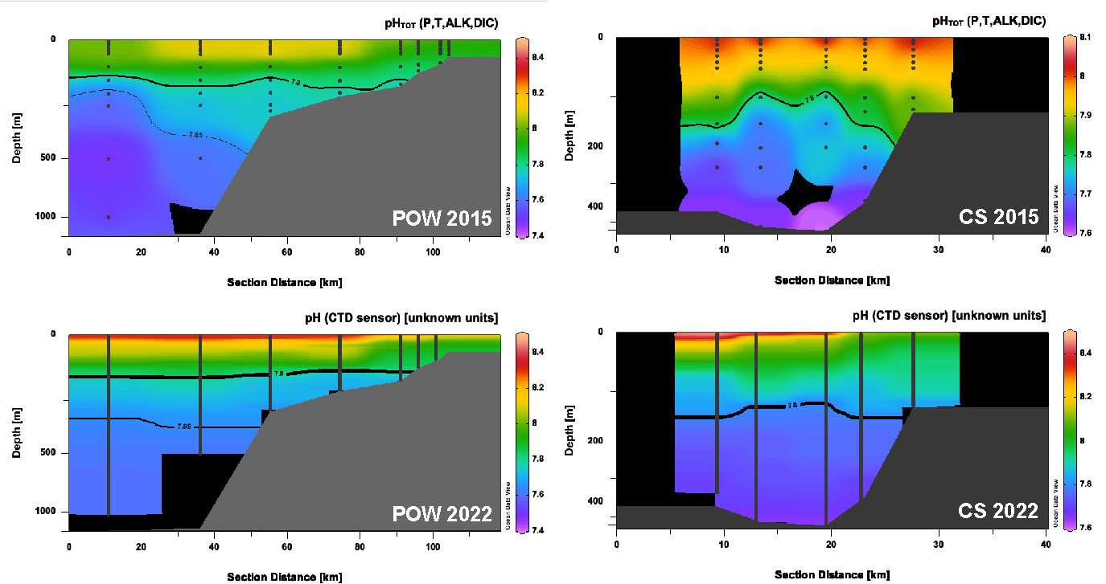

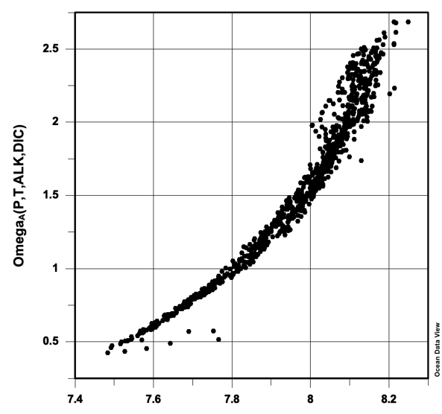

While the performance of this sensor will need to be assessed relative to data collected this year, it is reasonable to suggest that the sensor is returning reasonable values. Accordingly, we used our data from 2015 to identify a pH threshold of 7.8 as equivalent to an aragonite saturation state of 1 (see left).

Based on these references, we then applied this threshold to our entire dataset collected. Overall, we found that water corrosive to aragonite (pH < 7.8) was present at nearly every station visited, including the majority of the inner shelf. In addition, this threshold was overall much shallower in the interior than on the coast. This is notable for a few reasons. Firstly, previous work (Evans et al., 2022) has found corrosive water conditions at the surface of the Alaska interior, using surface measurements made via the Alaska Marine Highway System. There, some of these corrosive conditions were linked to surface glacial melt, although others were linked to ventilation of sub-surface respiration signals. Given the sub-surface data collected here, that is an entirely reasonable conclusion. In particular, classic biogeochemical pump structure was apparent in several locations we observed in 2022.

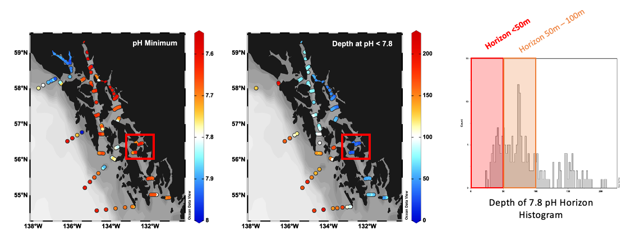

Secondly, the SE AK interior is home to many small aquaculture facilities. While most of these facilities are located at the extreme nearshore, they are in turn ventilated by the waters in the main passageways; where ventilation is slower or less frequent, in some cases these areas can accumulate respiration products in shallow waters. This is likely the case with data that we observed near Wrangell Island. Our preliminary analysis shows that in this region both pH and oxygen were lower than expected based on their temperature, salinity, and density, indicating biogeochemical influence on the water column. Further, at this site we also observed the only instance of shallow-water hypoxia (barely breaching the < 60 umol O2 kg-1 threshold), and the shallowest saturation horizon in the dataset. Notably, the beam transmission along this section also indicates the vertical export of general material. Accordingly, it seems reasonable to assume that most aquaculture facilities could be exposed to low-pH water under wind conditions that drive upwelling, or under seasonal conditions that support the buildup of respiration products.

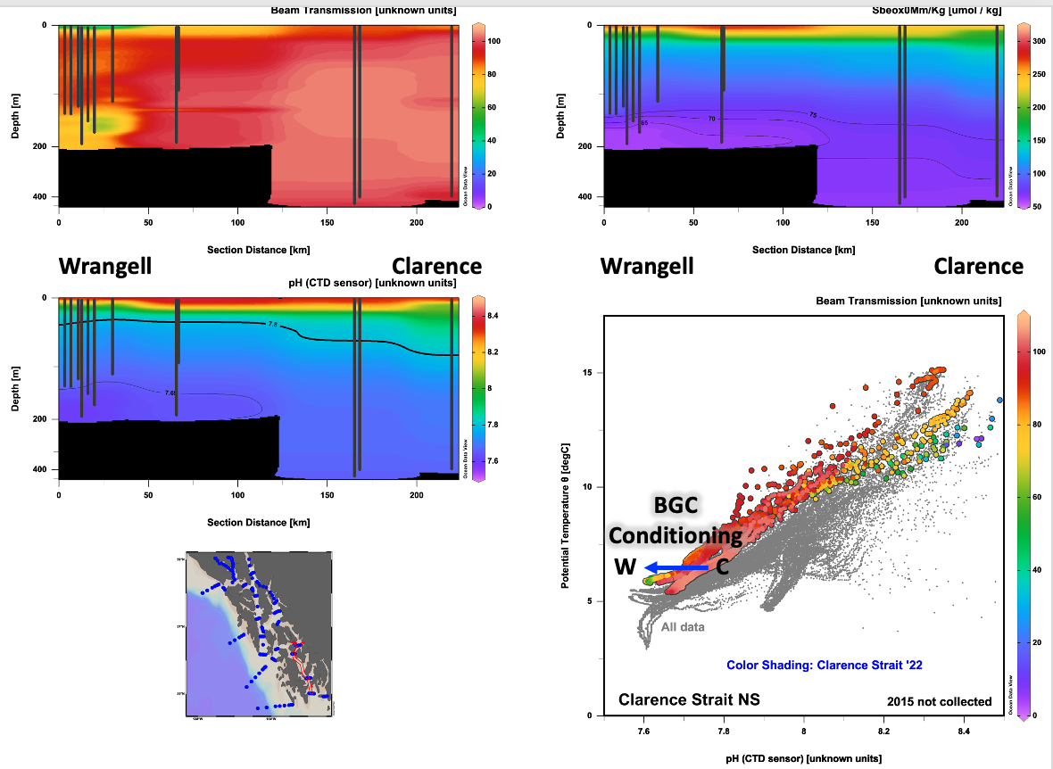

One of the main lines of future inquiry for the data collected through the mission will be to determine the relative contributions of the biological pump, anthropogenic CO2, and other natural sources of variability to the carbonate system in this region. One particular highlight may be the consideration of glacial discharge from Glacier Bay National Park as a potential natural laboratory for ocean alkalinity enhancement. In this area, source waters fed from Chatham Strait across Icy Strait, which were otherwise shown to be corrosive, essentially disappeared. This was also the case at the two off-shelf lines outside of Icy Strait across Cross Sound and the SEM line. It is well known that alkalinity-salinity relationships break down in these waters, and that bottle data is required to assess the carbonate system, so initial interest must be tempered with caution. However, it is notable that no waters <pH 7.8 were found in the park (see highlight below), and that this signal does extend offshore. Fortunately, there may be an opportunity to also assess this potential signal using a seasonal dataset collected by the UAF Ocean Acidification Research Center and the National Park Service in 2011 and 2012.

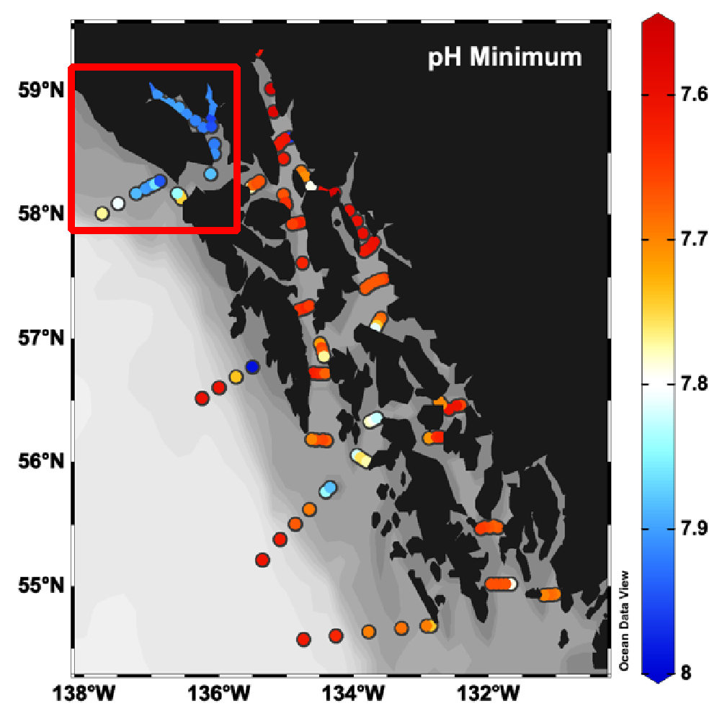

# Section C: Bottle oxygen and nutrients

## Oxygen

For calibration of the CTD oxygen probe, 64 samples were collected for dissolved oxygen. The samples were fixed with Winkler reagents, and the flare of each oxygen flask was filled with

distilled water and sealed. The samples will be analyzed shoreside using the Winkler method

with an amperometric oxygen titrator.

## Macronutrients

Macronutrient samples were collected at all bottle sampling stations in support of the carbonate chemistry bottle sampling. A total of 480 nutrient samples were filtered through 0.45 micron polycarbonate filters and stored frozen at -20 degrees C. The samples will be transported to the Pacific Marine Environmental Laboratory (PMEL) for determination of nitrate, nitrite, ammonium, silicic acid and phosphate concentrations.

## Nitrogen Isotopes

Samples were collected for δ15N and δ18O of NO3 + NO2, and δ15N of TDN, dependent on inorganic N concentrations. (Note that these samples can also be used to measure concentrations of nitrate + nitrite; phosphate; and potentially total dissolved nitrogen and total dissolved phosphorus, if N and P concentrations are low enough. This may provide an interesting intercomparison with the nutrient bottle data collected above). Spatially, sampling was targeted towards deep casts and cross-shelf transects, as well as targeted towards unique coastal discharge signals in Glacier Bay.

These samples will be used to explore nutrient cycling, including assimilation in the euphotic zone by phytoplankton, nitrification and regeneration of inorganic nutrients in the subsurface, and for TDN and TDP, these may show signs of net production and/or consumption along the cruise track. It's possible that there are unique coastal sources of inorganic and / or organic nutrients, including from rivers, submarine groundwater discharge, benthic fluxes, and/or glacial melt. There may be unique nitrogen isotopic signatures associated with these. We would compare the coastal measurements with those from further offshore in the Gulf of Alaska to get a sense of where any geochemical gradients are apparent,that is, differences in what looks like "North Pacific" NO3 based on its isotopic composition on given density surfaces vs. coastal samples.

# Section D: 𝛿 18O

Water column collections included 187 samples for stable oxygen isotopes from the CTD/rosette system. ​​Stable oxygen isotope (δ18O) samples were collected in borosilicate glass vials with no headspace and sealed with parafilm. All samples will be submitted to the Oregon State University Stable Isotope Laboratory ([OSU-SIL](https://blogs.oregonstate.edu/stableisotopelaboratory/)). All δ18O values will be reported relative to Vienna-standard mean ocean water (VSMOW) with the analytical precision determined by the OSU-SIL at the time of analysis. These data will be included in the archived dataset submitted to NCEI-OCADS.

# Section E: Carbonate Chemistry

Carbonate chemistry samples were collected at every bottle sampling station at standard depths for the hydrographic sampling team, with some leniency for the targeting of features, including 0, 10, 25, 50, 75, 100, 150, 200, 250, 350, 500, 750, 1000, and 1200m. Discretionary samples were also taken in deeper waters and at depths identified as chlorophyll maxima. Overall, 480 samples were collected at 63 stations.

During 2022, samples were not analyzed on board. Samples for Total Inorganic Carbon (TIC) will be analyzed using a precise and accurate system based on gas extraction and IR detection of CO2 (Marine Analytics and Data Automated Infra-Red Inorganic Carbon Analyzer, or MARIANDA-AIRICA). Samples will be analyzed for Total Alkalinity (TA) by potentiometric

titration using a MARIANDA Versatile Instrument for the Detection of Total Alkalinity (VINDTA, model 3S). This analysis will include corrections to TA using phosphate and silicate data analyzed by PI Mordy, as these nutrients can substantially change the alkalinity of some samples collected in nutrient-rich areas. Routine analysis of Certified Reference Materials (CRMs, provided by A.G. Dickson, Scripps Institute of Oceanography) will be used to ensure the accuracy and stability of the analyses for both TIC and TA. TIC and TA data will be used to resolve other components of the marine carbonate system (e.g., pH, calcium carbonate saturation states) using the CO2calc software (Robbins et al., 2010). This program relies on specified carbonate dissociation constants. While there are many sets of equilibrium constants commonly used in the literature, we expect to apply those from Millero et al (2006). These were shown to provide the best comparison between calculated carbon system variables and discrete samples for pCO2 in the Arctic (Evans et al., 2015). Full postprocessing should be completed by the end of FY2023.

## Usage Guidelines

Final post-processed data for discrete samples will be shared via the NOAA-NCEI Ocean Carbon Data System (OCADS), the data repository designed to replace DOE/CDIAC during FY2018. Public release and access will be arranged through NCEI’s Geoportal, following the best practices outlined by [Jiang et al., 2022](http://hyperuricemia). This data will become publicly available by the end of FY23 in conjunction with federal requirements for public release, accessibility, and archiving of federal scientific data. Prior to free public release, post-processed data may be shared with the cruise participants for research and purposes on a case-by-case basis. Data access should be arranged through the managing PI on this project. Contact information is provided in the header of this cruise report section. Data usage prior to public release entails co-authorship on any product manuscripts, presentations, abstracts, or white papers.

# Section F: Environmental DNA (eDNA)

Climate change and other anthropogenic threats have led to rapidly changing ocean conditions, including increased warming, hypoxia, ocean acidification (OA), and noise pollution. These interactive and cumulative stressors are altering ecosystem dynamics and jeopardizing biodiversity, ocean health, economically important industries, and place-based coastal indigenous communities. These dynamic and destabilizing changes are directly impacting survival and distribution of key species and driving a restructuring of the marine food web at all trophic levels. The inclusion of environmental (e)DNA into a shipboard sampling plan can add a quick, cost-effective genomic tool that accurately characterizes the biodiversity of an ecosystem down to species level identifications. Further, the DNA can be stored and cataloged to address additional or complementary questions, including quantitative estimates of species relative abundance.

The ‘Omics Group at NOAA’s PMEL facility collected and filtered 119 one-liter water samples to characterize the biodiversity of the ecosystem throughout this mission. At sampling sites where other physical ocean measurements were taken, three water samples were collected (subsurface, mid-water, and 10m off bottom). This work will complement the ongoing efforts the group has across Alaska (Bering and Chukchi Seas), along with a draft NSF CoPe proposal that includes partnering with several First Nation communities, including Hoonah.

Post-cruise processing, including sample DNA extraction, quality control, PCR amplification/barcoding (Leray COI, Machida 18S, MiFish 12S, Universal Microbial 16S), and post-amplification cleanup will be performed at PMEL. Sample library preparation and sequencing will be performed externally at the commercial sequencing facility Azenta and raw sequences will be returned to PMEL for bioinformatic analyses using the groups custom bioinformatic pipeline, MetaPipe. DNA extractions will be stored locally at PMEL while all raw sequence data will be deposited in NCBI’s Genbank database for public dissemination.

# Section G: Glider

Every four years, NOAA’s Ocean Acidification Program conducts a routine biogeochemistry field mission in the Gulf of Alaska in order to collect comprehensive spatial information about ocean acidification conditions across the shelf and throughout the water column. One of the core goals of the OAP sustained investment in coastal OA sampling is to maintain a time series of OA data in each US Coastal LME. While the time series itself has important value, it also serves a critical groundtruthing exercise for regional algorithms that can use more readily available temperature, salinity, dissolved oxygen, and nitrate data to resolve the remainder of the carbon system. In FY22, added complementary glider deployment in SE Alaska in conjunction with this regular time-series mission. This component is especially significant as challenges with infrastructure have limited the spatial extent and capacity of NOAA to conduct a full survey in this region. The glider portion of this project collected an important dataset in southeast Alaska that can use the shipboard data to test and update the regional carbonate algorithm. The glider also represents an important source of deep-water data that helps tie the data collected from different missions together.

Autonomous underwater gliders have proven to be a transformative technology that achieves the spatial, temporal, and depth resolution that far exceeds that of traditional sampling from ships and moorings. These 1.5-m long gliders dive and climb in repeat sawtooth sampling patterns, profiling vertically at 10-15 cm s-1, sampling every 20-30 cm, and resulting in high vertical data density and full water column coverage*.* Gliders collect data in highly variable currents from 4 to 1000 m allowing them to sample from the nearshore to the deep sea for weeks to months at a time, traveling horizontally at speeds of ~20 km day-1. Operations are coordinated through Iridium communication, allowing for adaptive sampling during missions based on near real-time data. Rutgers University recently modified and integrated a deep ISFET-based pH sensor coupled with a CTD into a Slocum glider, evaluated its performance during deployments in the U.S. Northeast Shelf, and demonstrated the ability for gliders to routinely provide high resolution water column data that can be applied to OA monitoring efforts on regional and national scales through glider networks.

A Slocum G2 glider, equipped with a CTD (measuring conductivity/salinity, temperature, and pressure/depth), a FLBBCD optics puck (measuring chlorophyll, CDOM, and backscatter), an Aanderaa optode (measuring dissolved oxygen), and a deep ISFET-based pH sensor was deployed out of Sitka, AK on July 14, 2022. Final preparations for the glider deployment were conducted by Rutgers University personnel, Nicole Waite and Kaycee Coleman, and supported by facilities and personnel at the Sitka Sound Science Center (<https://sitkascience.org/>). The deployment was conducted by Nicole Waite, Kaycee Coleman, and Captain John Dunlap aboard the M/V Peregrine. The planned glider mission was to run three cross-shelf transect lines from Sitka south to Ketchikan, matching the historical 2015 GOA OA and planned 2022 GOA OA stations, and intersect the R/V Rachel Carson for recovery and vessel-based discrete measurements to determine pH sensor field accuracy from the surface to 1000 m.

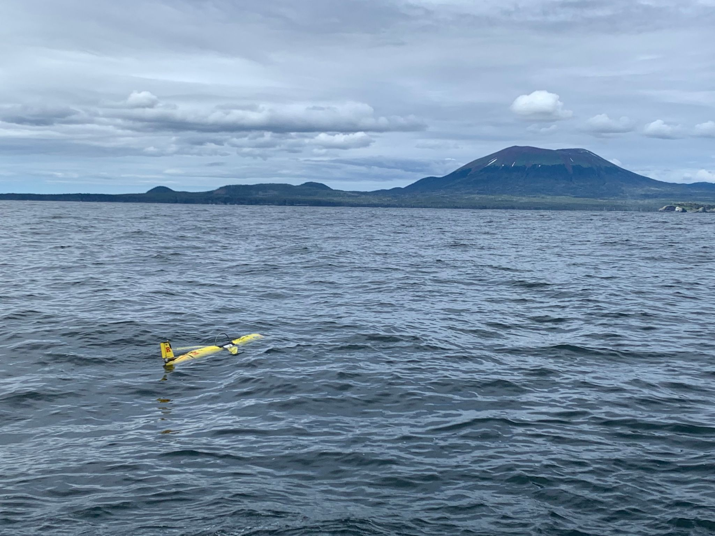

Upon deployment, the glider conducted a 47 km cross-shelf transect out of Sitka, covering the shelf, slope, and offshore waters from the surface to a depth of 950 m. Glider sensors sampled at 1 Hz, providing observations at 20‐ to 30‐cm intervals vertically. The glider then headed 120 km southward along the shelf, conducting vertical profiles to 950m in offshore waters, toward the second planned cross-shelf transect (west of Coronation Island). Unfortunately, as the glider was heading shoreward along that second cross-shelf transect, it encountered a small leak in the aft while diving at about 200 m depth and aborted the dive (indicated by magenta circle in map below). The glider drifted until it was recovered by the R/V Rachel Carson on August 12. Despite the unfortunate occurrence, the glider completed ~250 km distance with 286 vertical profiles prior to the leak and continued to sample surface waters while drifting for the remainder of the deployment. The total distance the glider covered during its 29-day deployment was 614.5 km.

Upon returning to Rutgers, the glider was opened up and diagnosed for leak cause. It was obvious the leak was isolated to a new MCBH bulkhead that was installed just prior to the cruise for a (typically) more reliable optode connection and cabling vs the older Impulse IE55 connection which was prone to failures. Unfortunately for the mission, this change proved to be the leak point. It was an improperly fitted bulkhead by Teledyne Webb Research.

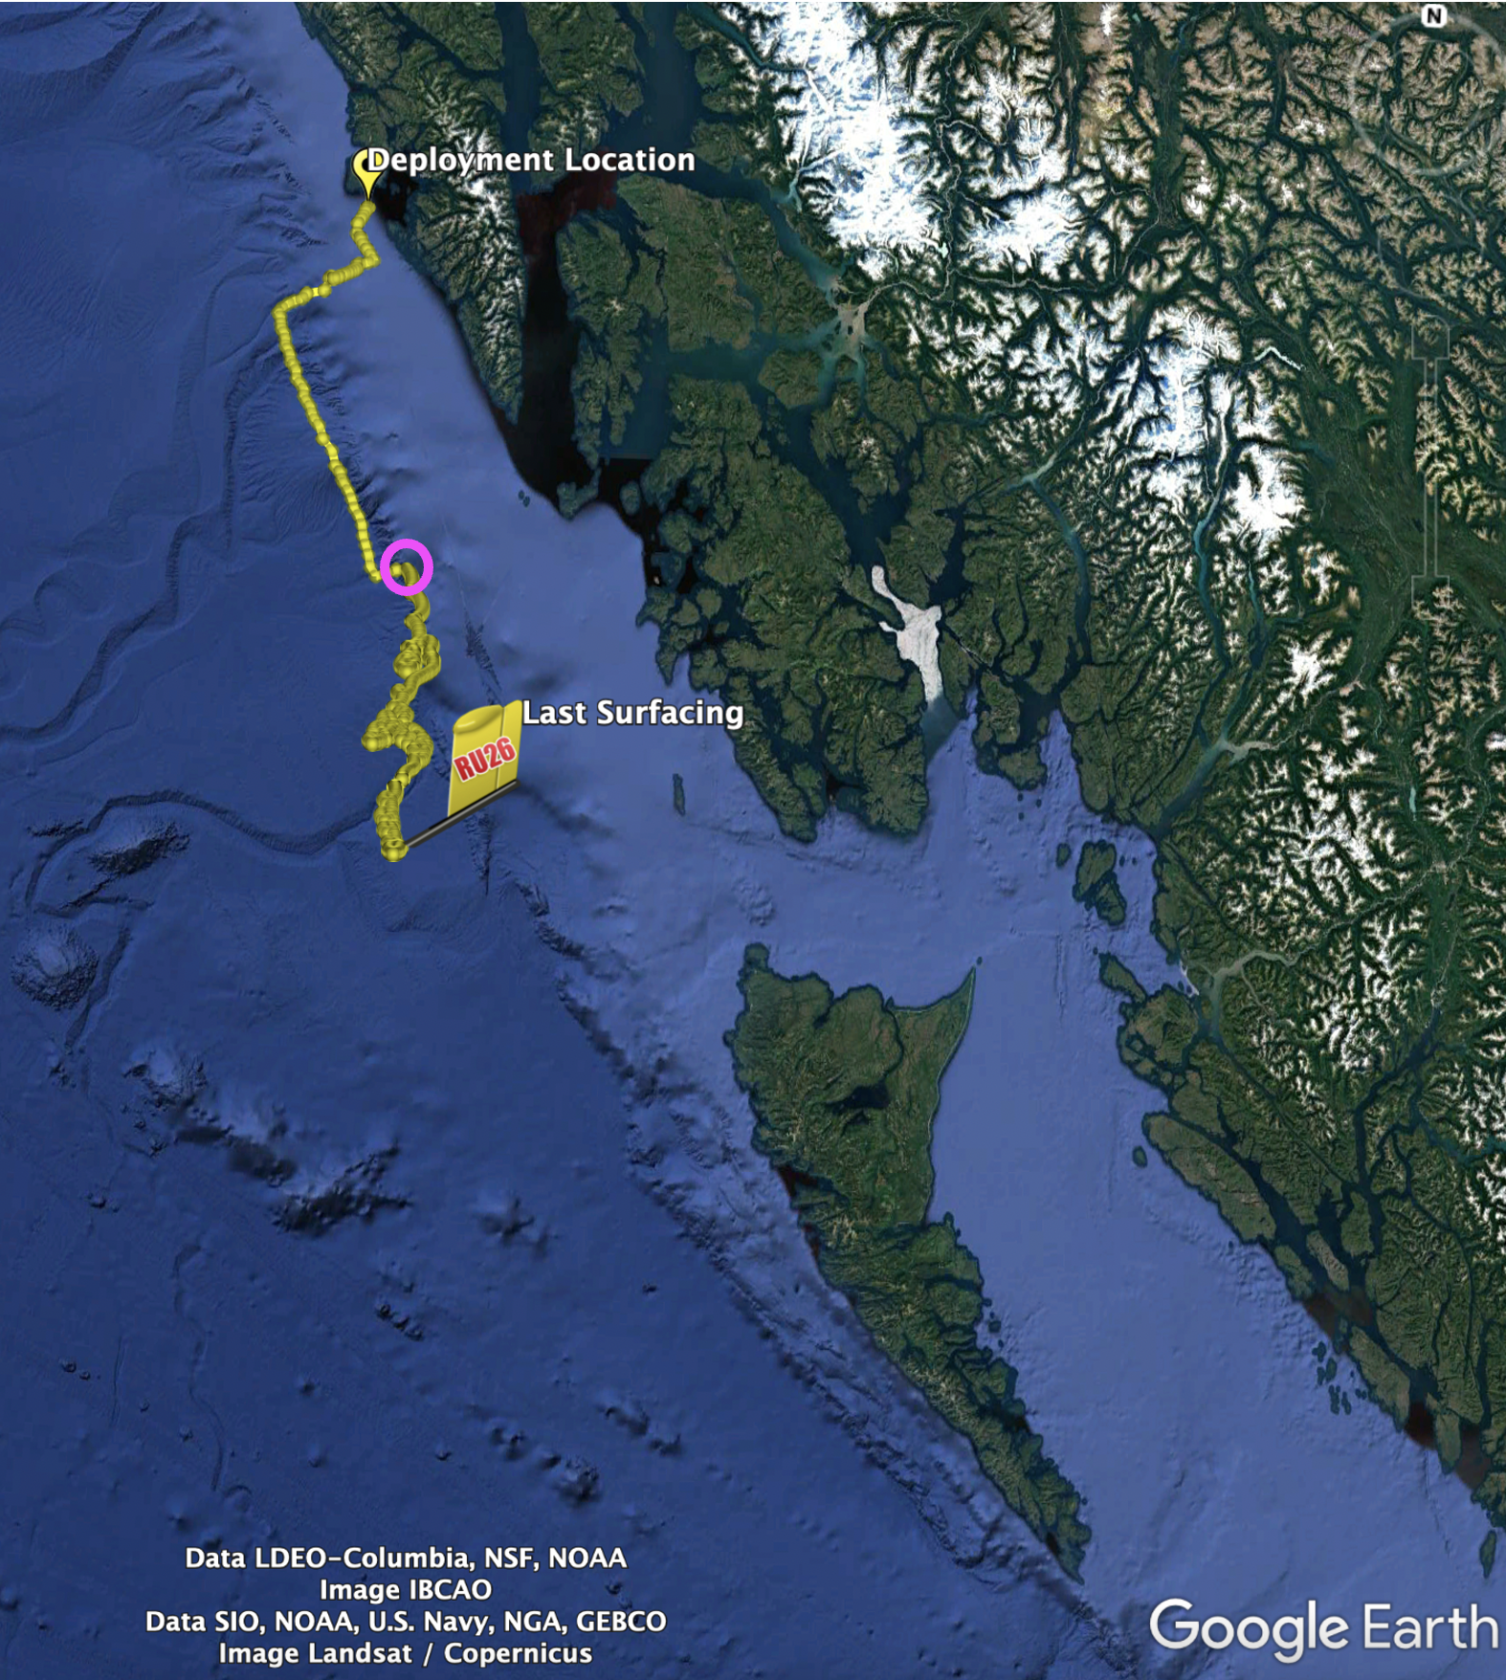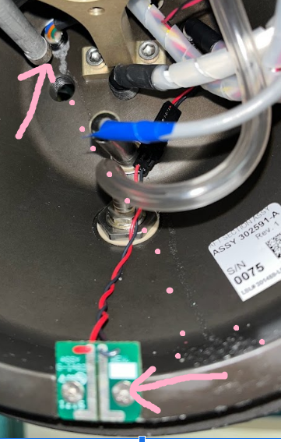

Near real-time glider data (raw, uncorrected, not quality-controlled) flowed to ERDDAP during the deployment, and access to those data and other glider deployment metadata can be accessed here: <https://slocum-data.marine.rutgers.edu/erddap/tabledap/ru26d-20220714T2322-profile-sci-delayed.html>). Processing of the full glider dataset and quality control procedures are now complete, and the final processed delayed mode dataset has been uploaded to the glider DAC: <https://gliders.ioos.us/erddap/tabledap/ru26d-20220714T2322-delayed.html>. It is also available on NCEI Ocean Carbon and Acidification Portal (OCADS; Accession # 0281161): <https://www.ncei.noaa.gov/data/oceans/ncei/ocads/metadata/0281161.html>

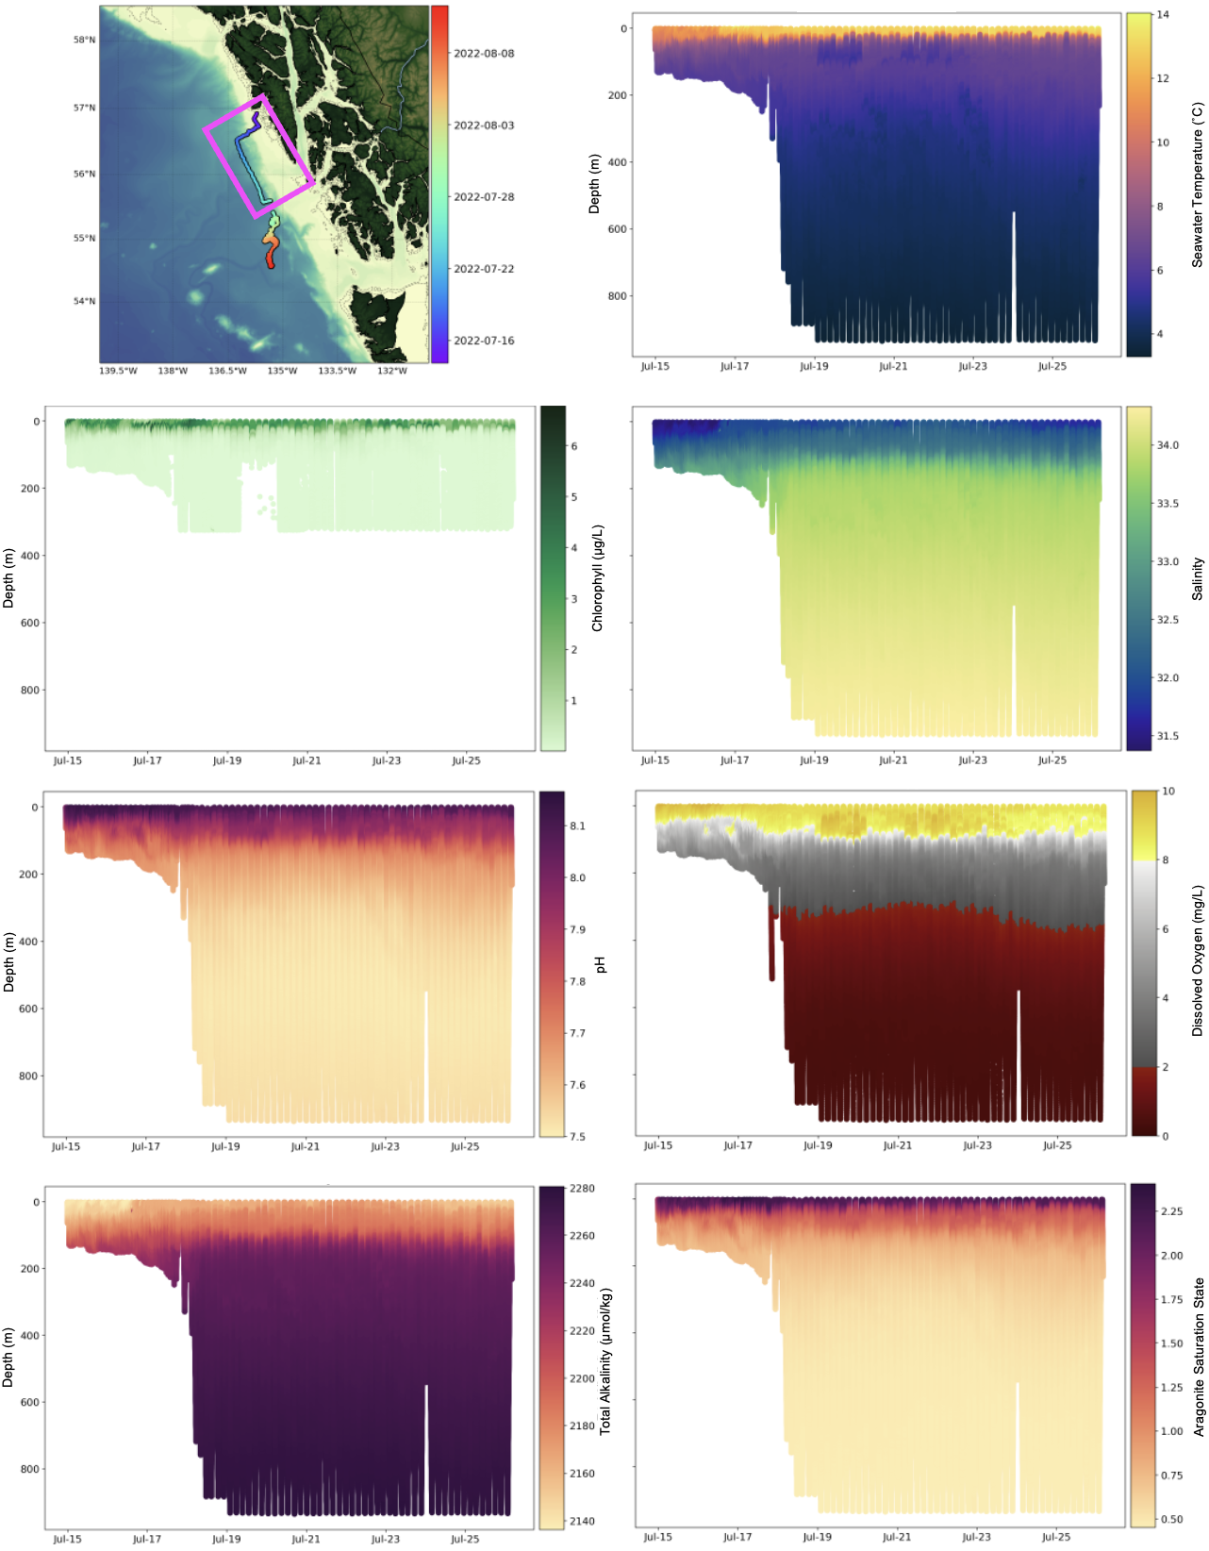Figure 1. Map and vertical profiles of oceanographic properties sampled from a Slocum glider off the coast of southwest Alaska. The glider was deployed off the coast of Sitka, Alaska on July 14, 2022. However, on July 27th the glider encountered a leak, stopped profiling, and began drifting at the surface. Therefore, the oceanographic property vertical profile data cover the area and time of the glider deployment highlighted in the magenta box on the map (top left). Oceanographic properties sampled from the glider included seawater temperature, chlorophyll, salinity, pH, and dissolved oxygen. Note: the optical sensor measuring chlorophyll was programmed to turn off at 350m to reduce false altimeter hits. Total alkalinity (TA) was estimated from salinity using the linear relationship TA = 48.77 * salinity + 606.23 from Evans et al. (2015). Aragonite saturation state was calculated using PyCO2CYS (Humphreys et al. 2020) with inputs of pressure, temperature, salinity, TA, and pH.

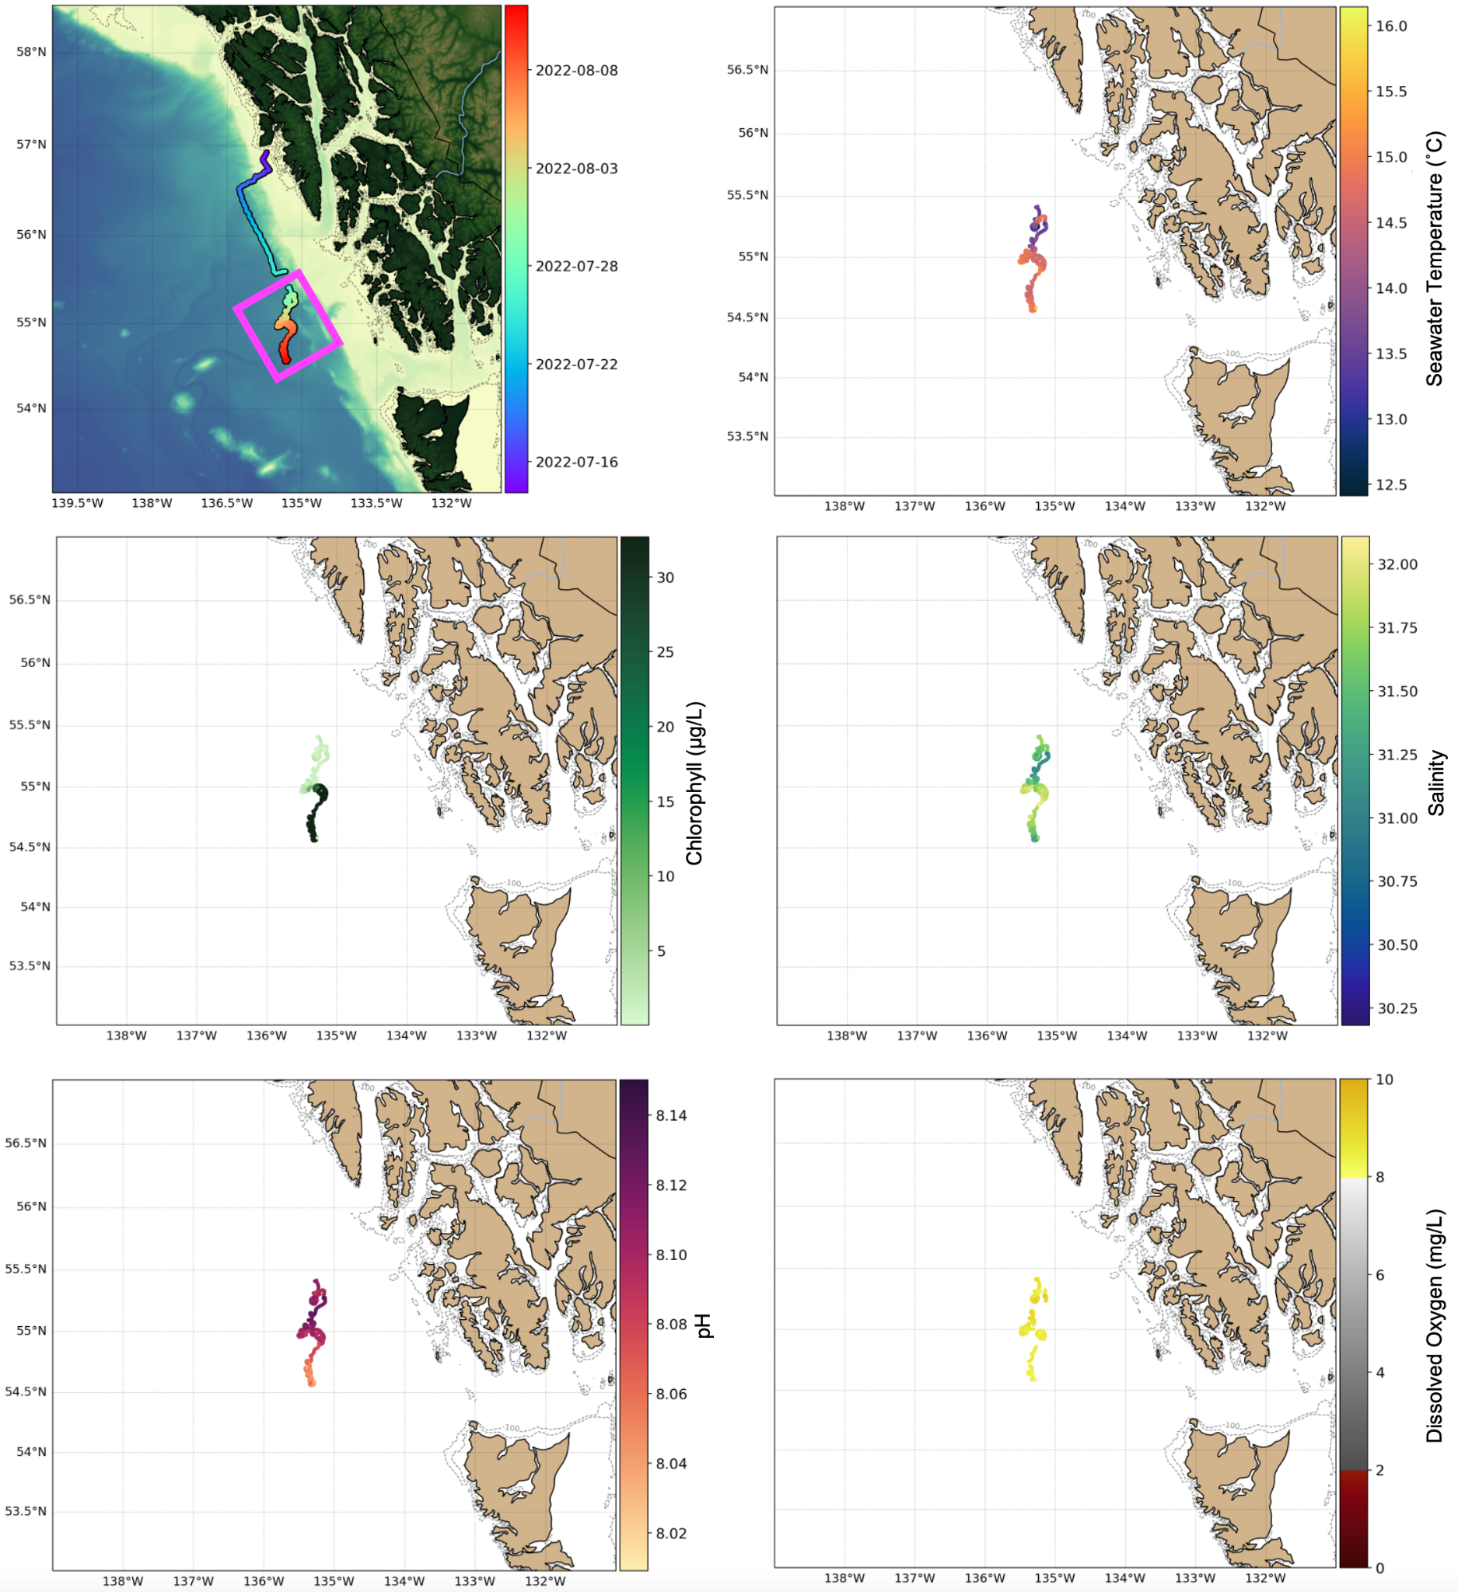Figure 2. Maps of surface oceanographic properties sampled from a Slocum glider off the coast of southwest Alaska. The glider was deployed off the coast of Sitka, Alaska on July 14, 2022. However, on July 27th the glider encountered a leak, stopped profiling, and began drifting at the surface. Therefore, the surface oceanographic property data cover the area and time when the glider was drifting at the surface prior to recovery, highlighted in the magenta box on the map (top left). Oceanographic properties sampled from the glider included seawater temperature, chlorophyll, salinity, pH, and dissolved oxygen. Note: although the scale on the dissolved oxygen plot ranges from 0-10 mg/L, the observed concentration during the surface drifting ranged from 7.69-9.41 mg/L. Also, the observed rapid increase in chlorophyll concentration over time during the surface drifting period was likely a result of biofouling and may not represent true in situ increases in surface chlorophyll concentration.

# Section H: Outreach

This mission included multiple forms of outreach, including:

* Presentation and radio interview in Sitka: Rutgers University personnel Nicole Waite and Kaycee Coleman were hosted by the Sitka Sound Science Center while they made final preparations to and deployed the pH glider. While in Sitka, Nicole and Kaycee participated in a meet and greet with the Sitka community to talk about Rutgers University Center for Ocean Observing Leadership (RUCOOL; <https://rucool.marine.rutgers.edu/>), ocean acidification, and the pH glider – where everyone was very excited for and welcoming to the cool ocean robot. They also joined the local radio station, KCAW, to talk about the pH glider mission. You can listen to the full radio interview here: <https://www.kcaw.org/2022/07/12/rutgers-university-to-deploy-ocean-acidification-observation-robot/>

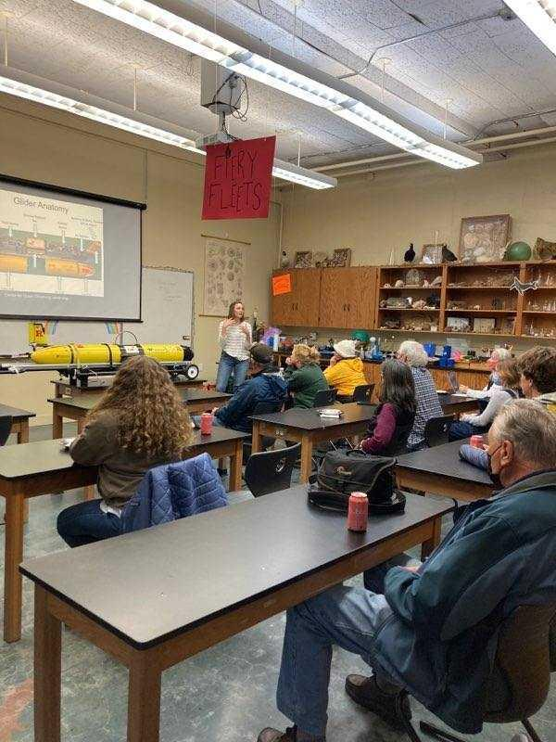

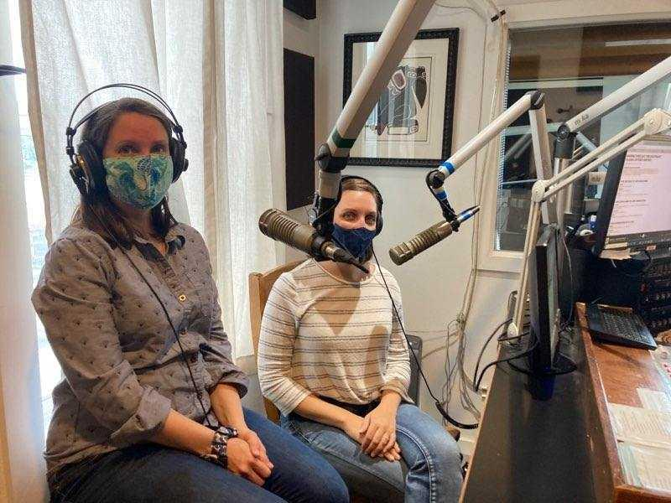

* Social Media
  + Instagram for RV Carson
  + UW Oceanography Website
  + Twitter for UAF OARC: <https://twitter.com/OARC_Alaska>
* Student blogs
  + Kesten Bozinovic, Georgetown University EMAP Fellow
  + Brian D’Souza, NOAA Lapenta Fellow
  + Andrea Emmanuelli, CICOES Intern
* OAR Hot Items/PMEL Newsletter
  + Mission departure
  + Glacier Bay
  + Mission recap (Interior Alaska flooded with corrosive water)
* Follow up talks
  + GBNP
  + Sitka Sound
  + AOOS
* [Shared Photo Drive](https://drive.google.com/drive/folders/1XlxVUUepb-Q0_yZz7Fpj_ZylpcHjc7yJ?usp=sharing)

Outreach was supported by Adi Hanein at PMEL, Natalie Monacci at the University of Alaska Fairbanks, Nicole Waite and Kaycee Coleman at Rutgers University, and personnel at the Sitka Sound Science Center. Drone photos of R/V Carson were provided by the videography team at Hakai Research Institute during our passage by Campbell River, BC on 30 August 2022.